PXE Network Boot Server:

Note:

DNSMASQ server which provides DNS & DHCP services.

Syslinux package: Bootloaders for network booting.

TFTP-Server (Trival File Transfer Protocol): Makes bootable images available to be downloaded via network.

VSFTPD: Host the local mounted OS DVD image, from installer extract its required packages.

Step 1. Install and configure DNSMASQ Server

1. One of your network card interface, should be static IP address from the same IP range that belongs to the network segment that will provide PXE services.

# Yum install dnsmasq



1. It is good to take backup of DNSMASQ config file, and then edit this file.



# vi /etc/dnsmasq.conf

1. Now, copy and paste the following configurations on dnsmasq.conf.

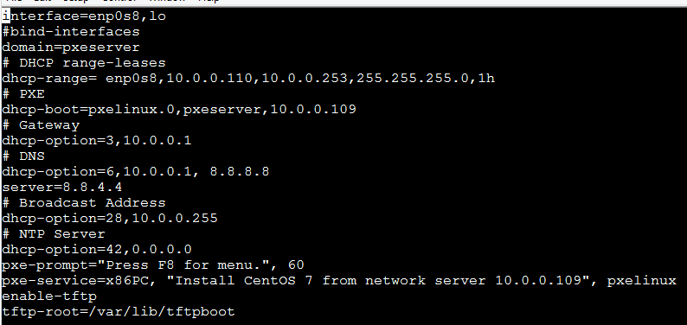

Step 2: Install SYSLINUX bootloaders

1. Install Syslinux PXE bootloaders package.



1. The PXE bootloaders files reside in /usr/share/syslinux absolute system path. We will copy all its content to TFTP Server path.

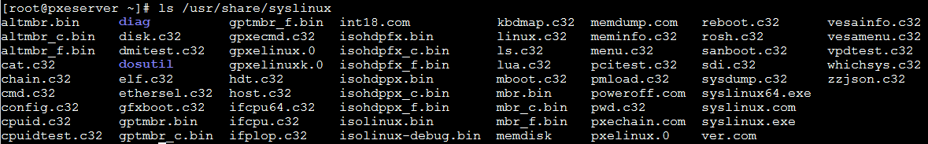

Step 3: Install TFTP-Server and populate it with SYSLINUX bootlloaders.

1. Install TFTP-Server and then, copy all bootloaders files provided by Syslinux package from the above listed location to /var/lib/tftpboot

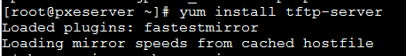



Step 4. Setup PXE Server configuration file

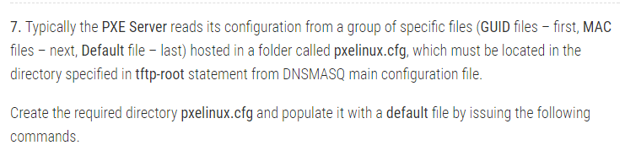

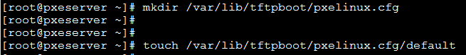

1. Now it’s time to edit PXE Server configuration file with valid linux distribution installation options. Also note that all paths used in this file must be relative to the /var/lib/tftpboot



8.

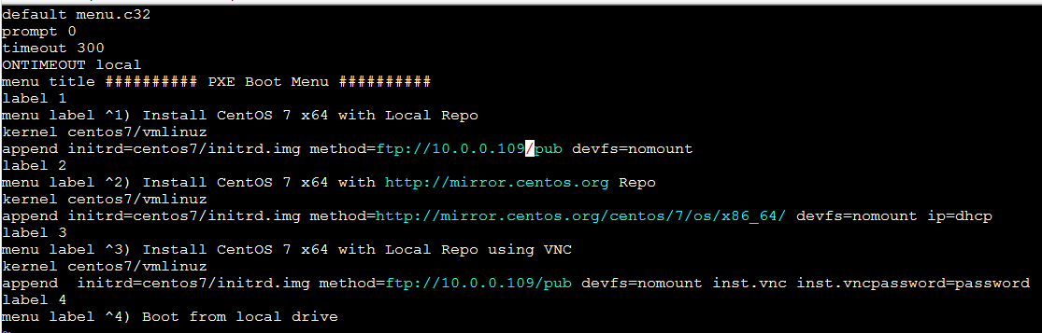

Step 5. Add Centos7 boot images to PXE server.

9.

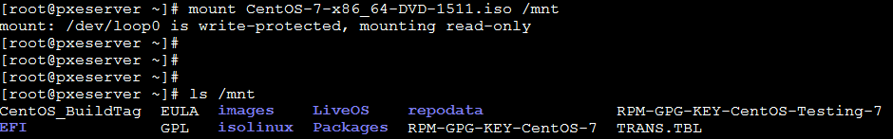

10. After the DVD content the made available, create the centos7 directory and copy centos7 bootable kernel and initrd images from the DVD mounted location to centos7 folder structure.





The reason for using this approach is that later you can create new separate directories in /var/lib/tftpboot path and add other Linux distribution to PXE menu without messing up the entire directory structure.

Step 6. Create Centos 7 local mirror installation Source.

11. Although you can setup Installation Source Mirrors via a variety of protocols such as HTTP, HTTPS or NFS, for this guide, I have chosen FTP protocol because is very reliable and easy to setup with the help of VSFTPD Server.

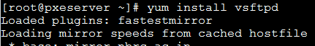





Step 7. Start and Enable Daemons System-Wide

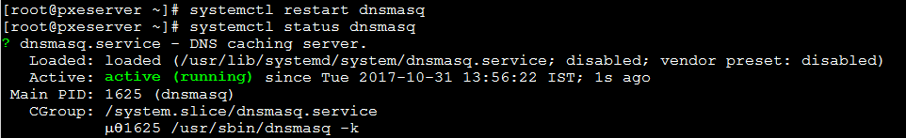

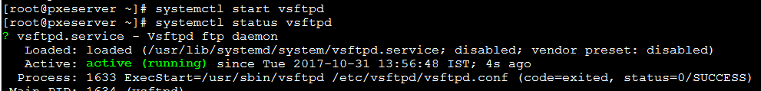

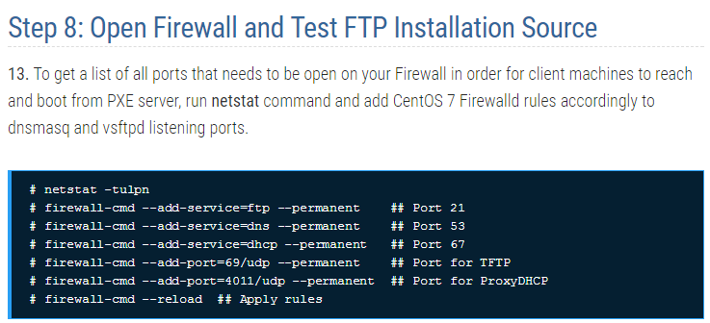

14. Test FTP installation source

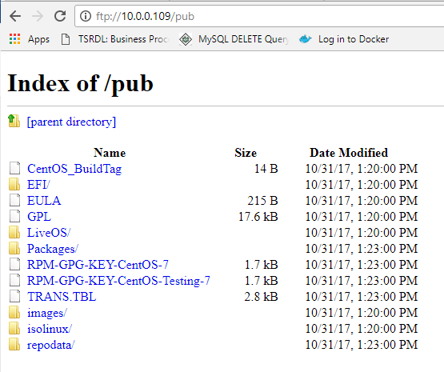

Step 9. Configure client to boot from network.

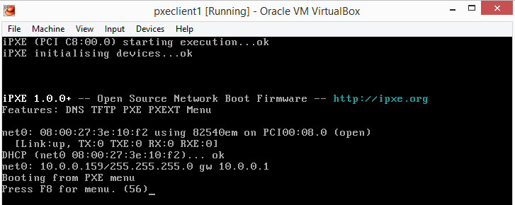

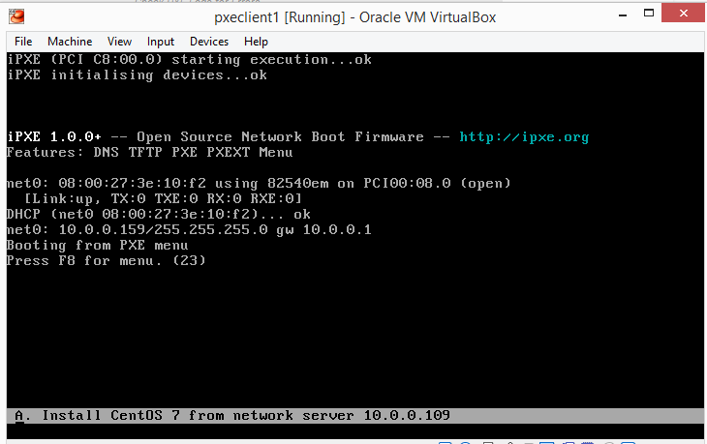

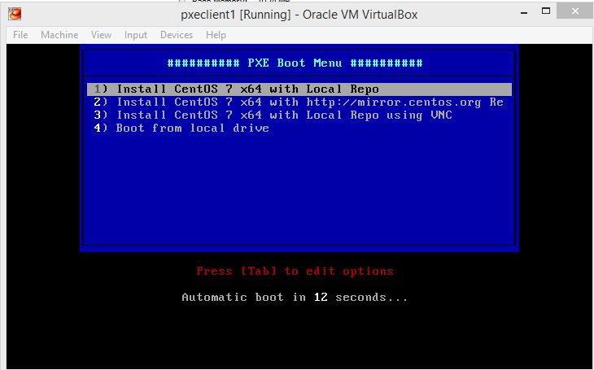

**Automated installations of multiple RHEL/Centos7 distribution using PXE boot Server and Kickstart Files.**

Note: Using KickStart file you can perform installations of RHEL/Centos7, without the need for user intervention, on headless machines using a kickstart file rad from a local FTP server.

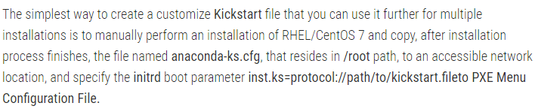

Step1. Create and copy Kickstart File to FTP Server path

1. Copy /root/anaconda-ks.cfg to vsftpd default server path (/var/ftp/pub) – also the path for RHEL/Centos 7 Local Mirror Installation source configured on PXE network Boot Server

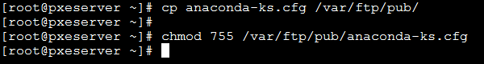

1. Edit the file



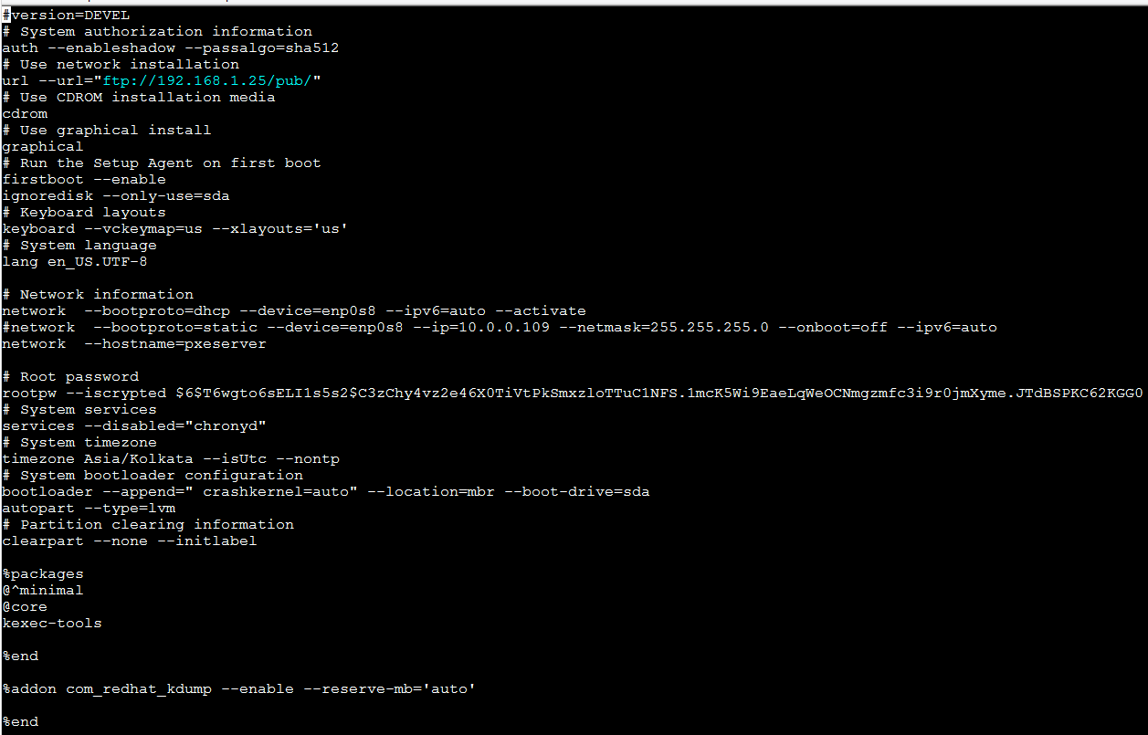

1. Install pykickstart package and verify your kickstart file by using below cmnd.





1. The last verification is to assure that kickstart file is accessible from your specified network location.

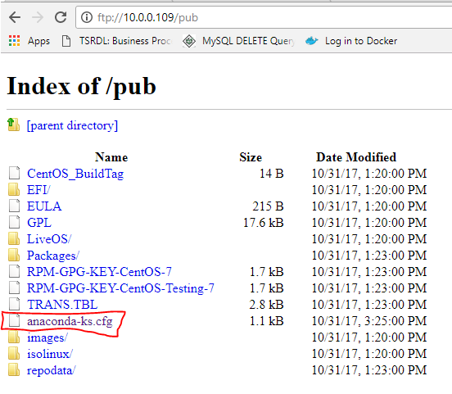

Step 2: Add Kickstart Installation label to PXE Server Configuration.



